### **Dimensionality Reduction**

**Question 1**: Note: In this question, all columns will be written in their transposed form, as rows, to make the typography simpler. Matrix M has three rows and three columns, and the columns form an orthonormal basis. One of the columns is [2/7,3/7,6/7], and another is [6/7, 2/7, -3/7]. Let the third column be [x,y,z]. Since the length of the vector [x,y,z] must be 1, there is a constraint that x2+y2+z2 = 1. However, there are other constraints, and these other constraints can be used to deduce facts about the ratios among x, y, and z. Compute these ratios.

**Answer:**

Let C1 be [2/7,3/7,6/7], C2 be [6/7, 2/7, -3/7] and C3 be [x, y, z]

The dot product of any two columns must be zero.

C1.C2 = (2/7 * 6/7) + (3/7 * 2/7) + (6/7 * -3/7) = 0

C2.C3 = (6/7 * x) + (2/7 * y) + (-3/7 * z) = 0 → 6x +2y -3z = 0 – Eq 1

C3.C1 = (x * 2/7) + (y * 3/7) + (z * 6/7) = 0 → 2x + 3y + 6z = 0 – Eq 2

2 * Eq 1 + Eq 2 → 12x + 4y -6z + 2x + 3y +6z = 0 → 14x + 7y = 0 → y = -2x

3 * Eq 2 – Eq 1 → 6x + 9y + 18z – 6x – 2y + 3z = 0 → 7y + 21z = 0 → y = -3z x: y: z = -2: 1: -3

**Question 2**: Find the eigenvalues and eigenvectors of the following matrix:

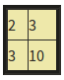

You should assume the first component of an eigenvector is 1. Then, find out One eigenvalue and One eigenvector.

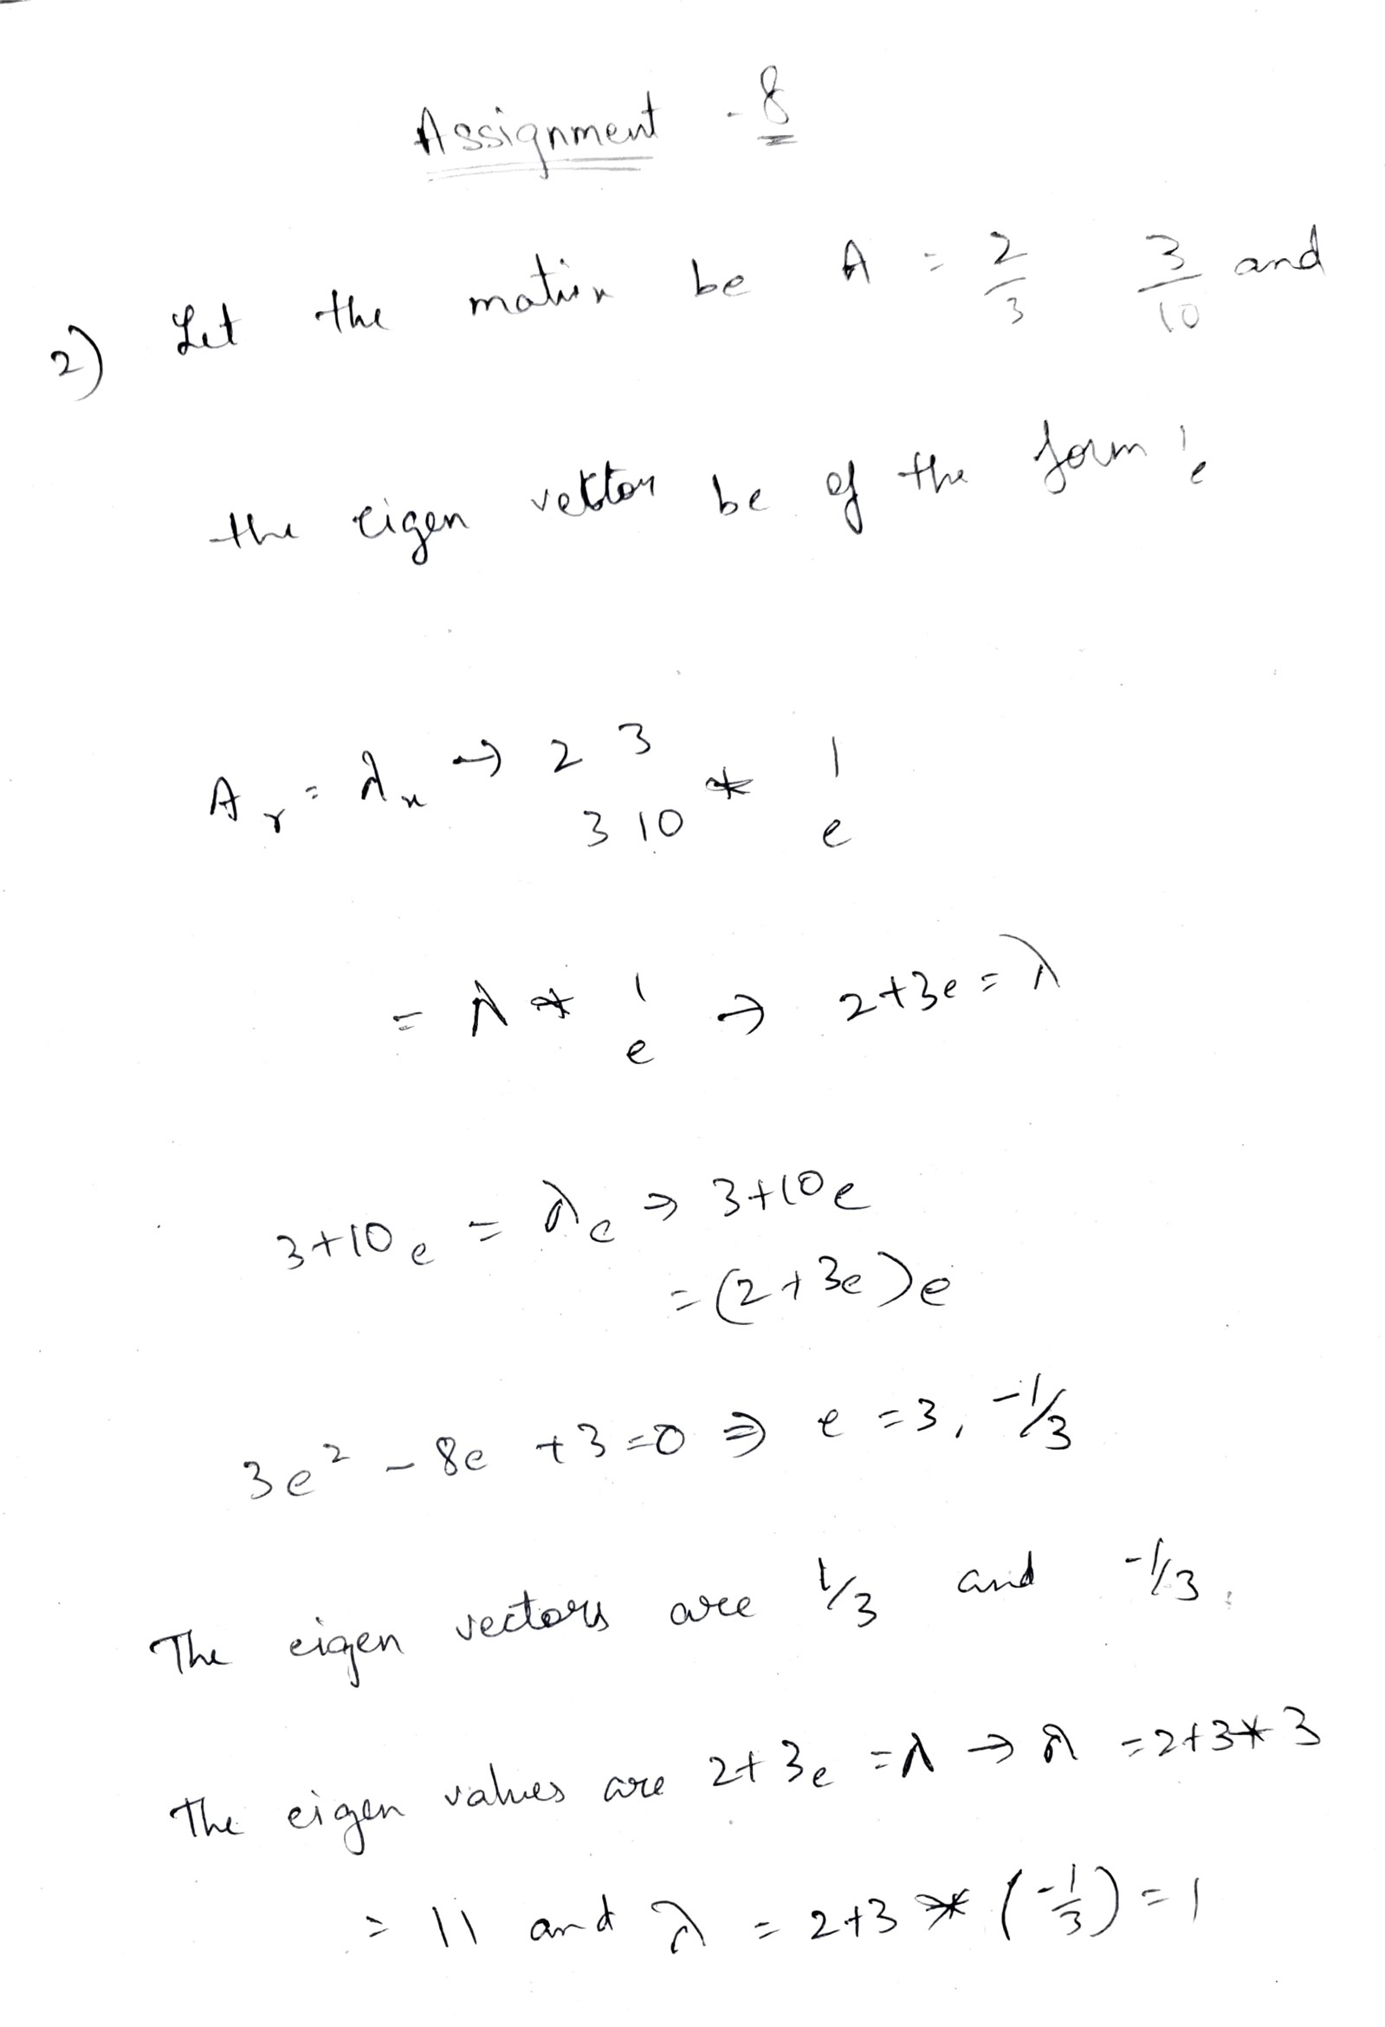

**Question 3**: Suppose [1,3,4,5,7] is an eigenvector of some matrix. What is the unit eigenvector in the same direction? Find out the components of the unit eigenvector.

**Answer:**

Given the eigen vector of some matrix be M = [1,3,4,5,7]

To get the unit eigen vector of given matrix, we need to divide each component by square root of sum of squares in the same direction.

Sum of squares = 1 2 + 32 + 4 2 + 5 2 +7 2 = 100 and its square root is 10

Unit Eigen Vector = [1/10,3/10,4/10,5/10,7/10]

**Question 4**: Suppose we have three points in a two dimensional space: (1,1), (2,2), and (3,4). We want to perform PCA on these points, so we construct a 2-by-2 matrix, call it N, whose eigenvectors are the directions that best represent these three points. Construct the matrix N and identify, its elements.

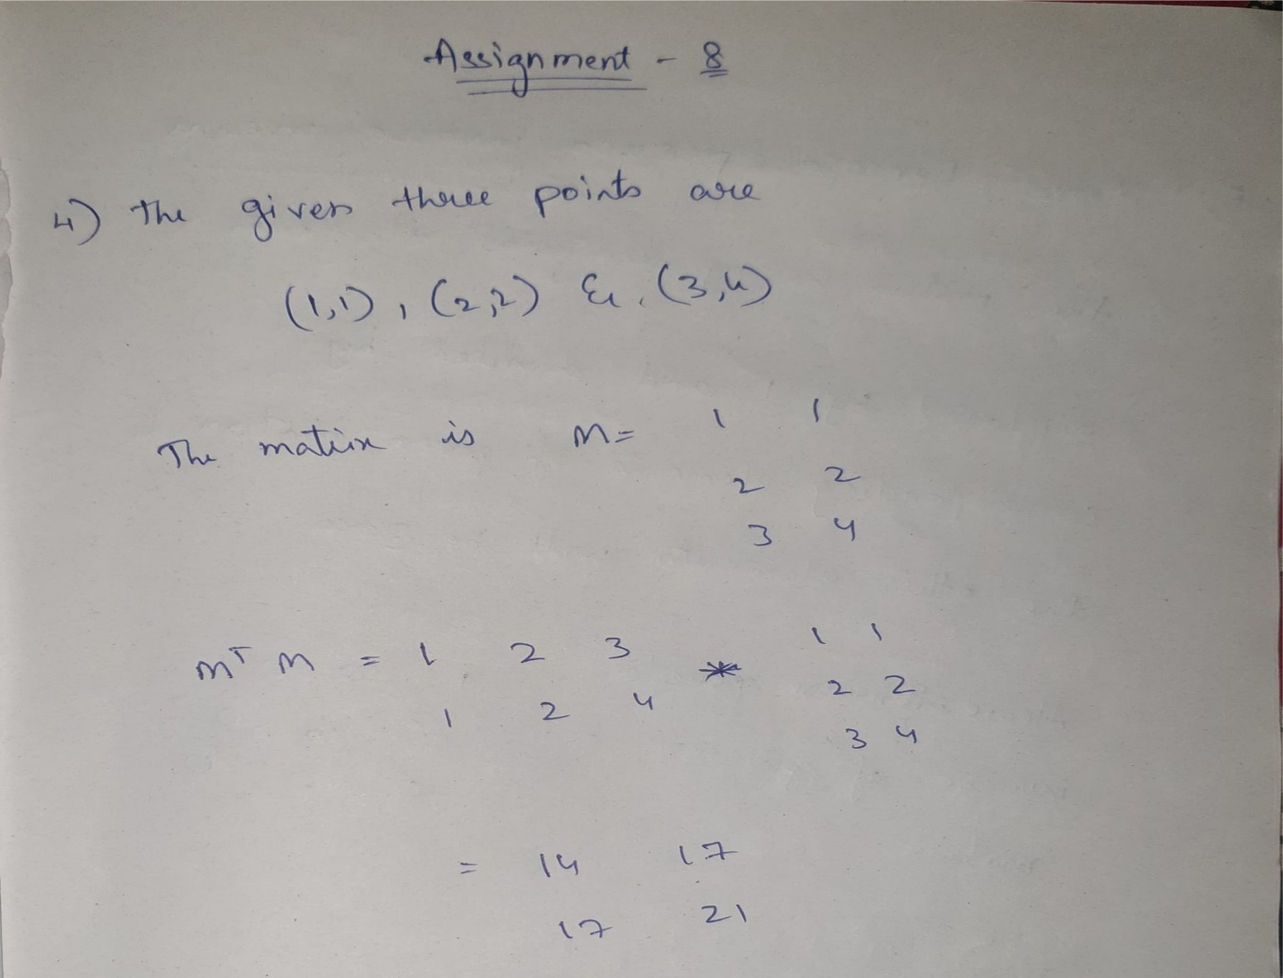

**Question 5**: Consider the diagonal matrix M =

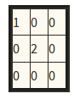

Compute its Moore-Penrose pseudoinverse.

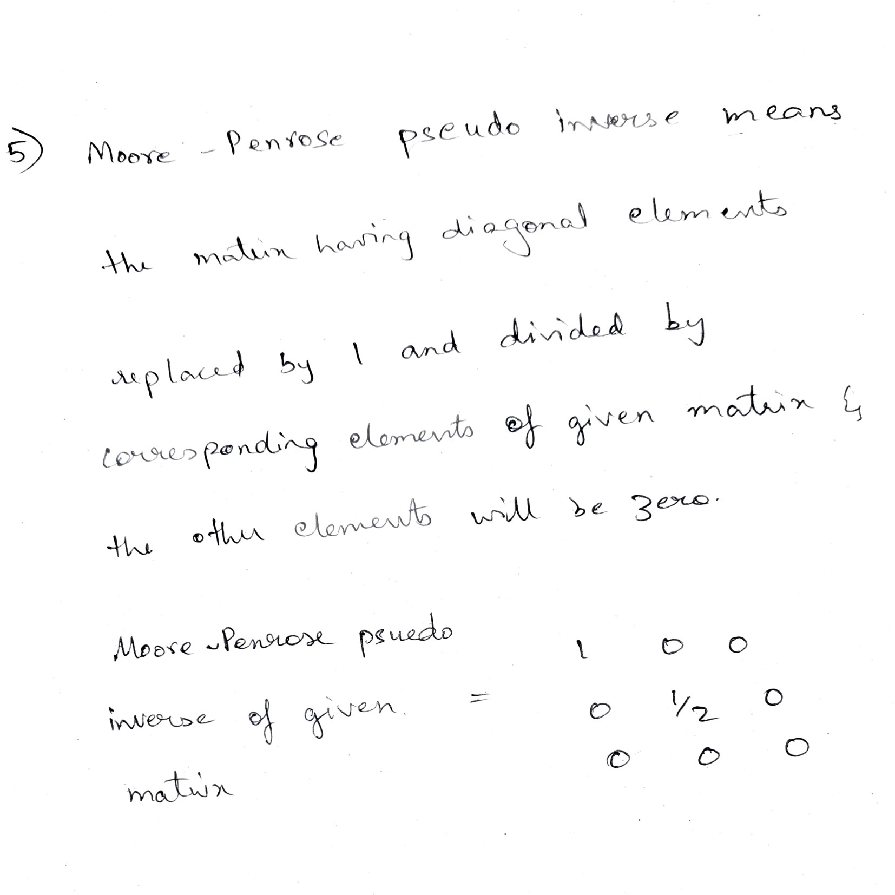

**Question 6**: When we perform a CUR dcomposition of a matrix, we select rows and columns by using a particular probability distribution for the rows and another for the columns. Here is a matrix that we wish to decompose:

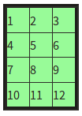

Calculate the probability distribution for the rows.

